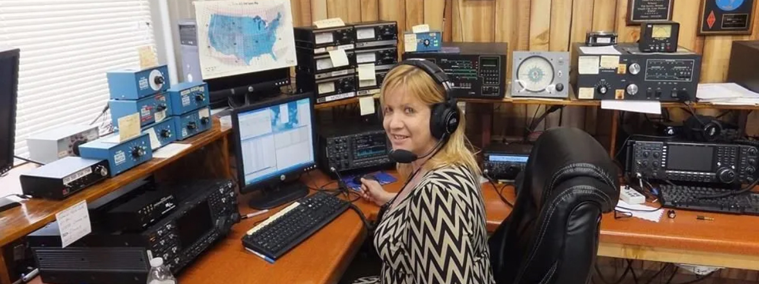
FREE Limited Ham Radio Technician Study Group! Spread the Word!
Starts Tuesday September 24th from 7:00 to 9:00Pm This is a 6 week study group.
We will meet at the Santa Cruz County Emergency Operations Center (EOC)
5200 Soquel Ave, Santa Cruz, CA 95062 (The green building with the golf ball on top)
PLEASE RESPECT OTHERS AND BE AT LEAST 15 MINUTES EARLY
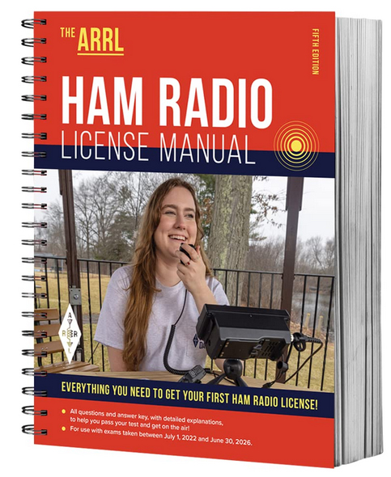
Hello,
Thank you for inquiring about the Amateur Radio Technician License study group!
Some things you need to know if you would like to join our group.
- The class is limited to 20 people, and please register
- You need to buy the ARRL Technician study guide. https://www.amazon.com/ARRL-Ham-Radio-License-Manual/dp/1625951558
- We will also be studying on line with a free web site: https://hamstudy.org/
- You do not need to know anything about electronics or radios.
- Please do not buy any ham radios till we talk about them and give you information on what works.
- Standard math used. No need to learn Morse Code.
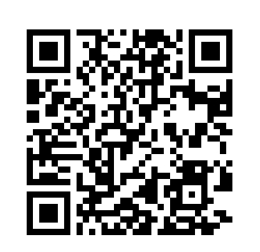
- There is no age limit! The whole family can do this as a project.
- We are going to have a lot of fun as we learn the excitement of ham radio.
- There will be demonstrations, samples of radios, antennas, electrical components and more!
- Local hams will be stopping by to say hello and encourage everyone.

The class is free, and brought to you by your local ham radio community.
Please register on Sign up Genius (non hams only please) for the class here (limit of 20 study buddies):
https://rebrand.ly/hamclass.

License exams to be announced later.

If you are already a ham radio operator and want to brush up on something you do not understand, please join us, but do not register. We ask that you do not participate in questions and answers during the class, we need to concentrate on those who do not have their license yet.
We can always talk after the class.

Hope you can join us! Bob Fike KO6XX

