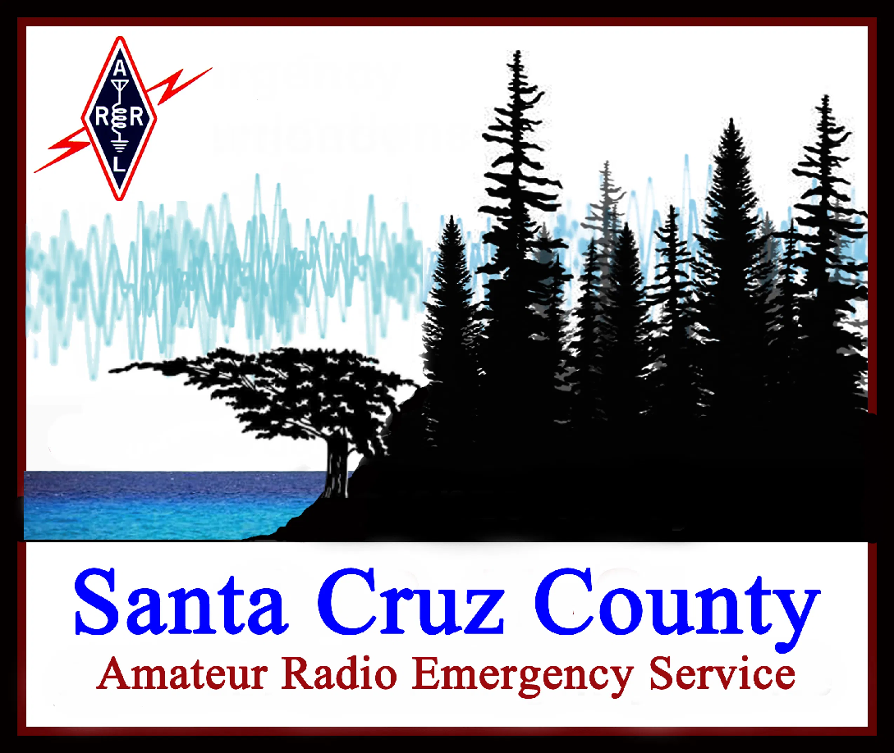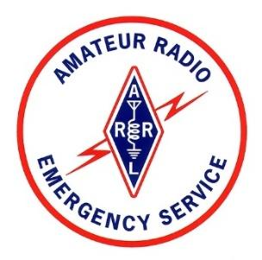

Welcome to the Santa Cruz County Amateur Radio Emergency Service (ARES) team. We are licensed amateur radio operators who voluntarily organize, train, and practice to provide emergency communications during and after a disaster. This guide will help you understand our local ARES organization and speed your participation in our activities.

To ensure we remain a trusted partner with our local public safety organizations, ARES members agree to complete training and maintain the skills and professional demeanor needed to work with people and equipment in difficult situations.

**Santa Cruz County ARES Organization**

ARES is a nationwide organization of the American Radio Relay League (ARRL). Joining the ARRL brings many benefits to a ham, but you don’t need to be an ARRL member to join us. Santa Cruz County ARES is led by District Emergency Coordinator John Gerhardt, N6QX. Contact him anytime at den6qx@gmail.com. Our new member coordinator Bob Fike, KO6XX, is always glad to hear from you at bob.ko6xx@gmail.com.

ARES members are registered with the county as Disaster Service Workers. Your DSW badge identifies you as a trained emergency service volunteer.

**Professionalism and Dependability**

We train to serve our community during emergencies. When deployed, we look neat and act professionally to maintain the trust of public safety agencies and the public.

Deployments may involve long periods out of doors, so dress for the weather and wear sturdy closed-toe shoes. All ARES deployments require an ANSI Class 2 or 3 yellow reflective safety vest, which helps keep you safe and identifies you as an emergency communication resource. *Santa Cruz Communications Support*, our nonprofit partner, supplies vests at no charge to ARES members at Level 1 and above. Some deployments have additional dress requirements.

When you take an assignment, we count on you to show up on time, equipped and ready. Deployments begin with a mandatory on-site briefing; if you miss the briefing, you’re not ready for the assignment.

**Regular Participation**

Keep your communications skills sharp: join our weekly radio nets, attend our monthly meetings, and participate in our exercises and public service events.

**Getting Started with Santa Cruz County ARES**

Here’s how to get a quick start with Santa Cruz County ARES:

|  | **Action** | **How to Do It** |
| --- | --- | --- |
| 0 | If you haven’t already, register to join ARES. | Go to <https://xczcomm.com/index.php/registration-form/> |
| 1 | Put yourself on the ARES mailing list | Follow the sign-up instructions here: <https://lists.xczcomm.com/mailman/listinfo/everyone> |
| 2 | Get a hand-held 2m/70cm radio | Not sure what radio to get? Look at our recommended equipment list: <https://xczcomm.com/index.php/equipment/> |
| 3 | Explore our website | Lots of good info at <https://xczcomm.com/> |
| 4 | Program your radio for local repeaters and simplex channels | See <https://xczcomm.com/index.php/frequency-list/>  Talk to the new member coordinator if you’d like help. |
| 5 | Participate in our weekly radio nets. | See the schedule here: <https://xczcomm.com/index.php/calendar-of-nets/>  Questions about our nets? Contact our net manager Roberta at roberta@slvares.org |
| 6 | Read about ARES training requirements and download the *Santa Cruz ARES Training Task Book* to keep track of your progress. | See <https://xczcomm.com/wp-content/uploads/2024/11/ARES-Training-Requirements-rev-9.pdf> |
| 7 | Register as a county Disaster Service Worker. | Go to <https://xczcomm.com/index.php/dsw/> |
| 8 | Get a Santa Cruz ARES ANSI Class 2 or Class 3 yellow reflective safety vest. (Don’t use a vest with a non-ARES logo for ARES deployments.) | Get one for free when you meet the requirements for ARES Level 1.  (See item 6, above.) |
| 9 | Participate in our regular training and public service events. | Join our monthly meetings and watch for our emails to learn about upcoming events. |
| 10 | Check out our You Tube channel | <https://www.youtube.com/channel/UCHZH8TUSgh4SqHTPXSWolPA?app=desktop> |